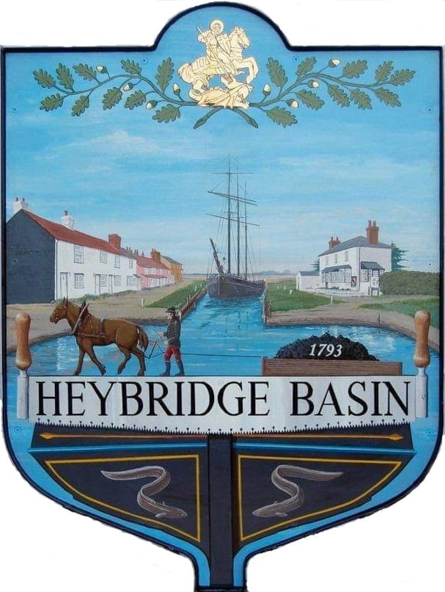

HEYBRIDGE BASIN PARISH COUNCIL

Minutes of the Extraordinary meeting of Heybridge Basin Parish Council held on Monday 4th March 2024 at 12.30pm, at St George’s Community Room.

PRESENT

In the Chair: M. Hodges (Chair) Absent: 0

Councillors: R. Bryson Apologies: 2
C. Edmond
M. Hobden Public: 0
C. Swann

Officers: G. Lake – Clerk

It was noted that this meeting was being recorded by the Clerk.

23/197 Chair’s Welcome
Cllr Hodges welcomed everyone to the meeting.

23/198 Apologies for Absence.
Cllrs Howat and Sjollema.

23/199 To receive Declarations of Interest in accordance with the Council’s Code of Conduct and with section 106 of the Local Government Finance Act 1992.
C. Edmond – Non-Pecuniary – Essex Waterways and Director of Cloughton Court Management Company Ltd and Cllr Hobden – Non-Pecuniary – HBSA, Basin Oars and HB Rivercare and Cllr Swann - Pecuniary – Business within DMCP.

23/200 Daisy Meadow Car Park (DMCP)
  - To consider the car park access road tenders and agree any action to be taken.
The DMCP Working Group met on Friday 1st March to discuss the revised tenders – only 7 revised tenders were received. The WG selected 3 for full council to consider.

It was resolved to delay the start date to the 2nd April to avoid disruption over the Easter Bank Holiday weekend.
It was resolved to remove ELS from the considerations as well as option 2 from WH Roads.
It was resolved for the Clerk to send a list of questions to Camway Group and WH Roads ready for Council to consider at the next meeting.
It was resolved to write to the owners of Rohan House with further information relating to the work outside their property.

There being no further business the meeting closed at 01:30pm
Provisional Date of the next Council Meeting Tuesday 12th March 2024

Clerk Contact details: clerk@heybridgebasinpc.org.uk
Website: www.heybridgebasin-pc.gov.uk

